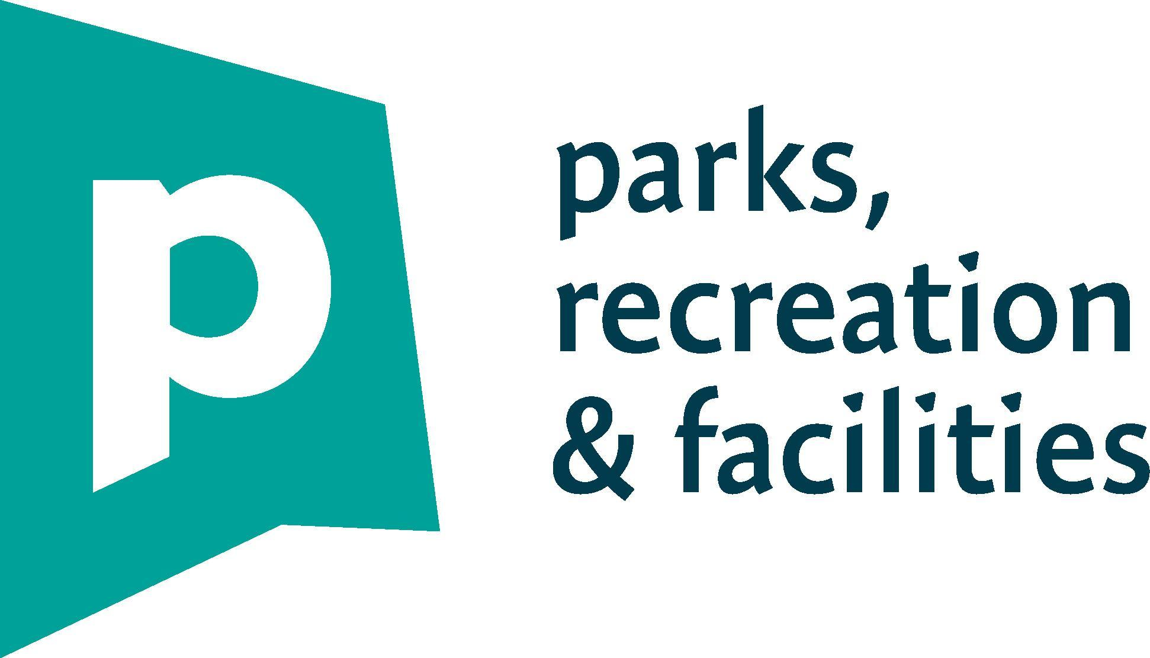

**5th &. 6th GRADE CALDWELL BASKETBALL LEAGUE**

**2023-2024**

**Season**

**Coaches Handbook**

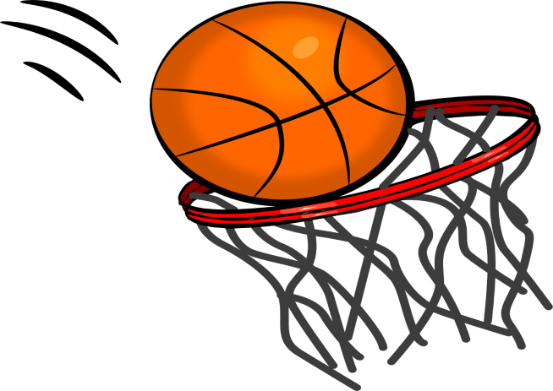

**Contact & Resource Information**

**Recreation Office**

* **Portland Recreation- 212 Canco Road, Portland Maine 04103**
* **Phone- 808-5400**
* **Cancellation Hotline- 756-8130**
* **Email- Nick Cliche-** [nc@portlandmaine.gov](mailto:nc@portlandmaine.gov) **or Angela O’Connor.** [aoc@portlandmaine.gov](mailto:aoc@portlandmaine.gov).
* **Phone- Nick Cliche- 808-5443**

**Portland Recreation Community Center Contacts**

* **East End-** Vacant

773-8222 [nc@portlandmaine.gov](mailto:nc@portlandmaine.gov).

* **Reiche-** Christiana Viney

874-8873 [cviney@portlandmaine.gov](mailto:cviney@portlandmaine.gov).

* **Riverton/Talbot-**

Brianne Maloney

874-8455 [bmaloney@portlandmaine.gov](mailto:bmaloney@portlandmaine.gov).

**Coach Resources**

[**https://www.breakthroughbasketball.com/coaching/youthbasketball.html**](https://www.breakthroughbasketball.com/coaching/youthbasketball.html)

[**https://jr.nba.com/category/basketball-skills-and-drills/**](https://jr.nba.com/category/basketball-skills-and-drills/)

[**https://www.usab.com/youth/news/2010/02/coachs-guide-teaching-the-fundamentals-of-the-game.aspx**](https://www.usab.com/youth/news/2010/02/coachs-guide-teaching-the-fundamentals-of-the-game.aspx)

[**https://www.coachesclipboard.net/BasketballFundamentals.html**](https://www.coachesclipboard.net/BasketballFundamentals.html)

**Important Dates 5th/6th Grade Basketball**

**Caldwell Basketball League**

* Saturday, November 18 - First day of games!!! Game dates: Nov. 18, Dec. 2, 9, 16, Jan. 6, 13, and 20. **If we have an odd number of teams, there may be double headers for 1 team each week.**
* Picture Dates:

To Be Determined: More information will be provided at a later date.

* Saturday, December 2 – No games at East End Gym. All games will be played at Riverton and Rowe Schools.
* Saturday, January 20 – Last day of games.

**5th/6th Grade Basketball Program Goals**

1. To provide a positive experience for all children that will keep them playing basketball for many years to come.
2. To teach all children the fundamentals of playing basketball. This league is a developmental league to teach children of all abilities.
3. To have children participate in an environment that doesn’t put any unnecessary pressure on them from parents or coaches. Children in this age group learn best with positive reinforcement.
4. To provide a fun environment that will help children grow emotionally, socially, and psychologically.

* This league is facilitated for the children who participate. We ask for your positive support while they are playing in this league. We would greatly appreciate the cooperation of the coaches and parents in facilitating these goals.
* The officials in this league are not board certified. These people work hard every day with the children in our programs. They work hard to maintain consistency, fairness, and good sportsmanship. We ask that the coaches and parents respect the calls of the officials during play; refraining from any negative comments.
* We appreciate your support and cooperation in making this a memorable and positive experience for all involved.

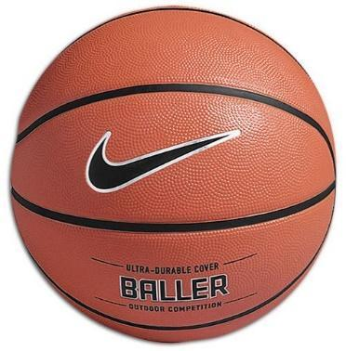

**5th/6th GRADE CALDWELL BASKETBALL LEAGUE RULES**

1. Portland rec disseminates one practice time per week for each team. Any additional times that become available will be released.
2. 8-minute periods – running time, 4th period = 9 minutes. Clock will stop for free throws, time-outs, injuries, long delays -laces being tied, long explanations...etc. **Clock will stop during the last minute of the 4th quarter in games within 5 points.**
3. **Person to Person defense will be played at all times**. NO Zone defenses. Defensive players must stay within arm’s reach of the player that they are guarding when the ball is one pass away. (Isolation plays are not allowed as they take away the opportunity for improvement for all players and contradict the spirit of the league)

**Double-teaming is not allowed**. However, Help Defense is encouraged in the following instances:

1. “Basket Line / Lane Area” - If a defender is in the lane (paint area) and the player being guarded is within approximately 6’, the defender is allowed to provide help by double-teaming. The intent of this exception is not to encourage a defender to remain near the lane at all times (“soft zone”) and double-team the ball each time it enters the lane. The intent is to teach a player “already in the lane” to play help defense.
2. Off Picks and Screens – Defensive switching is allowed on offensive picks and screens. At the appropriate time, players should return to guarding their assigned player.
3. Half Court Play – When an offensive player has beaten their defender, another defensive player may help. At the appropriate time, players should return to guarding their assigned player.
4. During Fast Breaks– When an offensive player has beaten their defender, another defensive player may help.

Penalty: There will be 3 warnings per half – on 4th call the other team will shoot 2 free throws for the remainder of that half.

1. Team fouls: 6 allowed per half – on 7th foul other team will shoot 2 free throws for the remainder of that half. Player fouls: 5 allowed per game – on 6th foul player will be fouled out of game.
2. One and one free throws take place in the last minute of each half if a team is in the bonus (7). All other free throws are shooting fouls only or violation of the double team rule.
3. No full court press except for the last 2 minutes of the game (close games only). If the game is within 10 points with 2 minutes to go, you may press. Defense must fall back to at least half court during other portions of the game. On all inbounds passes defense must allow 3 feet.
4. The 10 second rule is in effect to get the ball over half court.

1. Alternate possessions – determined by opening tip off.
2. Overtime is one 1-minute period, if the score is tied after the overtime period the game ends in a tie.
3. 2 time-outs per team per half, No Half Time will take place. Unused timeouts don’t carry over to the 2nd half.
4. Referees/League Coordinator will dictate match ups on the floor as opposed to coaches doing so. Matchups should be based on skill, not gaining the competitive advantage.
5. If a team is up ahead by 20 points at half time the score will be reset to zero to start the 3rd period.
6. Teams must have all players play an equal amount of time for each game. Playing time charts are provided so coaches can keep track of playing time.
7. Substitutions every 4 minutes during the 1st three periods. 4th period sub every three minutes. Exceptions will be discussed between referees and coaches.
8. The league does not keep team records or have playoffs.
9. **\*\*\* Questioning calls\*\*\*** As stated above, our referees are not board-certified officials. If a coach has an issue during the game, that coach needs to use one of their timeouts to discuss the particular issue and meet with the officials away from the bench and score table area.



In order to coach a team in the Portland Parks and Recreation Basketball League, I agree to the Portland Parks and Recreation Code of Conduct, which states as follows.

I will:

* Conduct myself in a dignified manner relating to emotions, language, attitude and actions
* Act at all times to protect the principles of fun, safety and development of all athletes
* Demonstrate respect for the ability of opponents as well as for the judgment of referees, officials and opposing coaches
* Display control and professionalism at all times under any circumstances
* Respect the rights, dignity and worth of every person, including opponents, other coaches, officials, administrators, parents, athletes, and spectators
* Refrain from physical contact with athletes except where necessary for the development of the athletes’ skill(s) or athletic ability
* Be aware and understand the role and influence of a coach as an educator, imparting knowledge of skill as well as proper personal, academic, and social behavior
* Be reasonable in my demands on athletes' time, energy and enthusiasm
* Provide an opportunity for all athletes to play the sport in game action according to the rules of the league
* Ensure that equipment and facilities meet safety standards and are appropriate to the level of the athletes
* Seek to learn the latest coaching practices that take into account the principles of growth and development of athletes
* Agree to abide by all applicable Portland Parks and Recreation’s rules and regulations, including all policies held within the organization. **Deviation from this agreement is grounds for removal from the league, and prohibition from attending future games and practices.**

**Four Steps to Improve Coach-Official Relations:**

1. Coaches should introduce themselves to and thank the officials prior to a game.
2. Coaches should never raise their voice.
3. If a coach has a question about a call, they should wait until gameplay stops, then approach the official in a respectful manner.
4. Coaches should always thank the officials after concluding a game.

Date: __________________________________________________________________

Signature: __________________________________________________________________

**5th/6th Grade Caldwell Basketball League**

**2023-2024**

***Coaches Checklist & Notes***

* Are your rosters up to date? All players must be registered with Portland Recreation
* Do you have practice space and times arranged?
* Call/Email the players on your roster as soon as possible and set up your first meeting and practice. This is a good time to invite the parents for a meeting and have parents sign Code of Conduct.
* Do you have other coaches to help you? Don’t do it alone. Recruit parents as assistant coaches if necessary. A team “mom” and/or “dad” are always helpful.
* Are you aware of any medical and/or emotional needs of your players? Make sure that you communicate with parents about any special needs/concerns.
* Remember, don’t get caught up with the wins & losses, this is a recreational basketball league for all abilities that emphasize participation and basic skill development
* Please remind players:

-To change into game sneakers when they arrive at the gym for both practice and games.

-No glass containers in the gym—bring plastic containers only!

- Do not wear jewelry during the games—this includes earrings!

* **PLAY HARD, PLAY FAIR, AND HAVE FUN!!!!!!!!!!!!!**
* Questions? Comments? Concerns? Contact Briane Maloney, League Coordinator at 874-8455 or email at [bmaloney@portlandmaine.gov](mailto:bmaloney@portlandmaine.gov).
* Coaches- If you have any game day issues or concerns, please speak with our on-site coordinator at your facility.

**THANK YOU FOR BEING A VOLUNTEER COACH!!!!!**

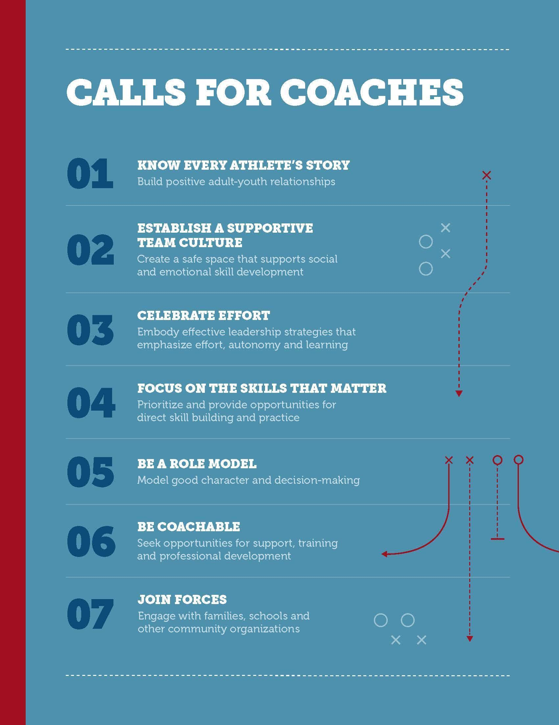

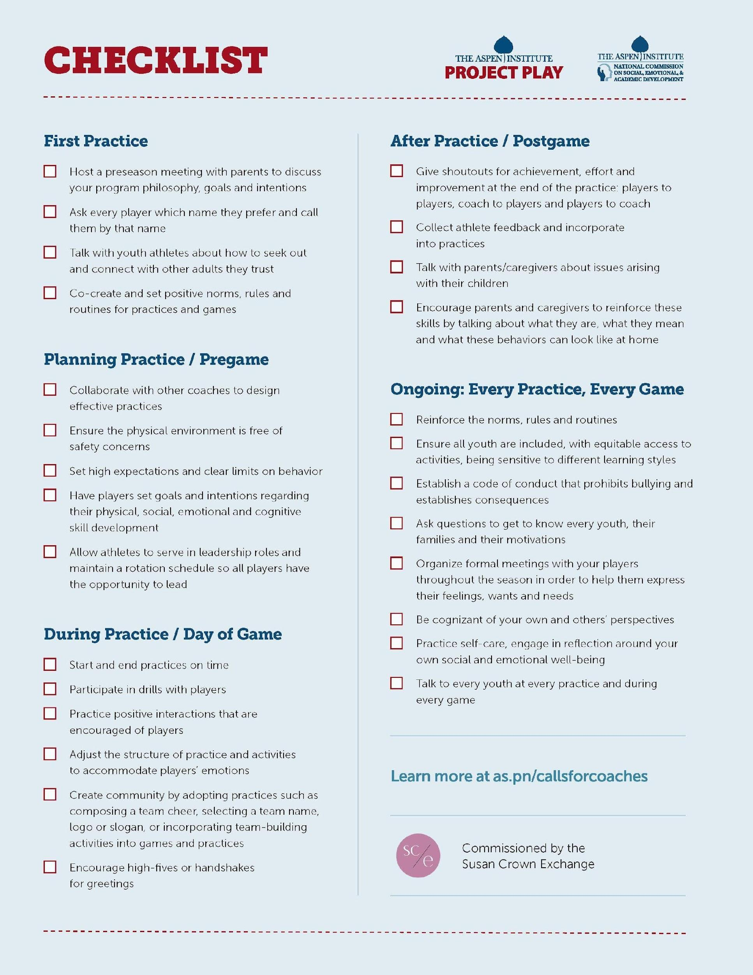

**Administrative**

**Introductory Letter**

We encourage coaches to send an introductory email to all the parents before the first practice. Just a few lines explaining your objectives and what the parents should expect over the course of the season. Below is a sample:

Parents,

Welcome to the Portland Rec 2023-2024 5th/6th Grade Caldwell Basketball Season! My name is Joe Smith, and I will be the head coach of DUKE this year and I look forward to coaching your child. I am writing to tell you a little about my approach to youth athletics and to let you know what to expect through the end of the season.

**Objectives:**

Equal Participation - Promote Good Sportsmanship -Teach the fundamentals of the game

Make it FUN.

**Practice:** Please list where and when practice will be located. Make sure to note parents need to pick up and drop off on time.

**Games:** 8 games with the first being on November 10th, games will be played at three different sites this year: Rowe Elementary, East End, and Riverton Community Center. Schedules will be distributed the week of November 5, 2018. Our team name is…

**Weather**: Weeknight practice‐ If the schools are closed or early dismissal due to bad weather then practice is cancelled if it is at one of the Portland Public Schools. If practice is held at Riverton or East End, those are subject to determination by the City as they are community center buildings. Saturday games‐ I will notify you if they are cancelled via phone call or email. Cancellation Line: 756 -8130

**Pictures:** Our game schedule will show which site we will be taking pictures at. An additional picture schedule will come out with time of arrival on the date of pictures.

**Uniforms:** Two sided t-shirts are provided by the league and will be provided at the games on opening weekend! Please have your children wear gym shorts with no pockets to each practice and game.

Any parents that are willing to help coach are welcome. I will have a schedule prepared for each practice and there will be meaningful work for any parent willing to help. Whether parents are on the court providing instruction or on the sideline providing support, the best approach is to oﬀer positive words of encouragement. This will help the players out immensely.

**Practice**

Practice and games should focus on the fundamentals of basketball. At the start of each quarter or substitution, players will meet at the center court and have a meeting with an oﬃcial. The oﬃcials will discuss fouls and other violations and give example when possible.

We encourage coaches to work on individual skills at each practice and as the season progresses, work on team plays. Each hour-long practice should consist of a practice overview, warm‐up and drills. The drills should cover diﬀerent elements of basketball including shooting, dribbling, passing, defense and rules. We have found that breaking teams into small groups and rotating children through diﬀerent skill stations is the most eﬀective way to keep children involved in practice.

**Essential Skills for 5th/6th Basketball**

1. **Lay ups / Shooting**- You should practice lots of layups with both hands. Your goal should be to get all players to make lay ups with their left and right hands equally well! Teach them to jump off the proper foot. They should jump off the left leg when shooting a right-hand layup. They should shoot off their right leg when shooting a left-hand layup. It will be difficult but work on it. You'll probably need to start really close to the basket, with no dribble, and take just one step to practice the footwork. Once you add the dribble, they should dribble with their left hand when shooting left hand layups. And vice versa. **Shooting –** emphasize good shooting form- squaring up to the hoop, elbow in and using legs to power the shot.
2. **Footwork** - Teach them triple threat positioning, pivoting on their left and right foot without traveling, jump stops, and to square to the basket as soon as they catch the ball in a triple threat position. You should spend a lot of time on footwork!
3. **Ball handling**- You should teach your players to dribble with left and right hands equally. Basic dribble moves such as the speed dribble, crossover, protect-the-ball dribble, and back-up dribble.
4. **Passes**- Teach and practice the basic chest, bounce, and overhead passes. As players advance you can teach the wrap around pass and baseball pass.
5. **2 vs. 2 & 3 vs. 3** - Play plenty of 2 on 2 and 3 on 3 games to teach concepts (no dribble keep away). It gets the players more experience and allows them enough space to operate and use the new skills they have learned. We play 3v3 to start the season!
6. **Offense** – Avoid structured or patterned offenses to start the season. First, get them comfortable on the court. Your main concern should be to have them move & not stand still.  Teach a few basic cuts and maybe screens in your shooting drills at the beginning of practice, then your players will already know how to move in a motion offense.
7. **Screens - T**each basic screens and a “pick and roll”
8. **Defense** - Teach the basic stance, defensive slide, basic off-ball principles and how to avoid screens. Focusing on it 5 to 10 minutes per practice would be more than sufficient. Basic Off Ball Principles: - Stay between person and the hoop - Always stop the ball if it is in front of you!
9. **Rebounding** – Teach players to box out and be active rebounders on both sides of the court.

**SAMPLE PRACTICE OUTLINE**

**7:00 – 7:05 - Discussion -** Bring the kids in for a brief meeting to explain what they will practice. Make sure they are not playing with the basketball while you are speaking. Establish yourself as the person in charge. A good way to get the children's attention is to ask them to raise their hand if they are listening.

*Rules – Come to the center with energy and enthusiasm. Listen to the coaches when they speak. Mistakes are OK. Treat everyone else like you would like to be treated. Plan for practice‐ Go over the practice outline

**7:05 – 7:10 - Warm‐up/Stance -**Start with a light movement drill such as mirror defense or stationary ball handling drills just to get their muscles warmed up. Foot Fire, Quick Jumps, down and back etc.

**7:10 – 7:30 - Drills for individual-** Practice individual skills such as dribbling, shooting, passing rebounding, defense, etc.….

*Passing Circle* **-**Call name out of player you will pass to. Receiver – show hands to passer. Means they are ready to receive the pass. Passer – Bounces pass. One step. Push hands hard through ball. The pass should hit the ground a little more than half way to the receiver. You can do this with a chest pass, overhead pass etc.

*Layups -*  Start close to hoop. Take one step with the jumping foot, drive knee high, and do a one footed take oﬀ. If you are doing a right-handed lay‐up you should be jumping oﬀ your left foot. You can start this with (Air Lay-Ups – No Ball) to emphasize form.

*Rebound Drills - Teach* players how to properly box out, rebound and outlet pass.

*Dribbling -* Have players work on dribbling the ball with both hands. This can be done with a partner, teaching a defensive stance at the same time.

**7:30 – 7:33 - Water**

**7:33 – 7:50 - Team Drills-** Practice team related skills such as defense, oﬀensive plays, transitioning, scrimmaging, etc.…

Position / Screen & Roll Play / Slide Relay Race/Scrimmage – 3 vs.3

**7:50 – 7:55 - Fun Ending Activity-** Always end practice with a fun positive note. Relay races, dribble‐ tag and shooting competitions are examples of a good ending to a practice.

**7:55 – 8:00 - Wrap‐**