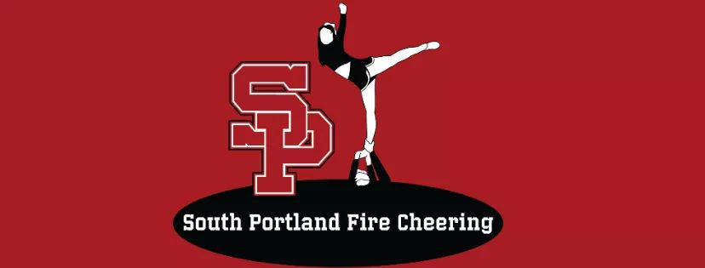
Family Code of Conduct
Athlete and Parent Code of Conduct
2024 - 2025

SPFC is a member of the Maine Youth Cheerleading Coaches Association (MYCCA) and is therefore required to have an athlete and parent Code of Conduct. I hereby pledge to provide positive support, care, and encouragement for my athlete, their team, their coaches, and the SPFC program by following this Code of Conduct:
- I agree to encourage good sportsmanship by demonstrating positive support for all athletes, coaches, and officials at every competition, practice, or other event.
- I agree to insist that my child practices/competes in a safe and healthy environment.
- I agree to provide support for coaches and volunteers working with my child to provide a positive, enjoyable experience for all.
- I agree to demand a drug, tobacco, and alcohol-free sports environment for my athlete and agree to assist by refraining from their use at all practices, competitions, and events.
- I agree to remember SPFC is an inclusive program and does not have any skill requirements for any teams.
- I agree to do my very best to make youth cheerleading fun for my child.
- I agree to have my athlete treat other athletes, coaches, fans, and officials with respect regardless of race, sex, creed, or ability.
- I agree to help my athlete enjoy the youth cheerleading experience by being a respectful fan.
- I will insist that my athlete’s coach agrees to the Coaches’ Code of Ethics Pledge.

Communication and Professionalism:
- I will never criticize, ridicule, or demean an opposing team, its athletes, coaches, or fans by word or gesture.
- I will never participate in publication or commentary on social media platforms any content that could be deemed derogatory about MYCCA, SPFC, coaches, athletes, officials, or opposing teams/coaches.
- I will represent SPFC in a professional manner at all times.
- I will comply with the decisions of directors, coaches, and officials and observe all rules, policies, procedures, as established or endorsed by the MYCCA league.

Social Media Expectations:
Athletes, coaches, parents, and volunteers must follow the code of conduct standards when publishing and/or commenting on social media while representing SPFC, or when it could be reasonably inferred they are acting in their capacity as a representative of SPFC.

